Placement Empowerment Program

Cloud Computing and DevOps Centre

Topics: Linux Introduction, VMs, and Commands

Faculty: Dr. M. Karthi

STUDENT NAME : JOSHUA MOSES

Register Number: 312323205103

Date: July 28, 2025

Contents

1 Task 1: Virtual Environment Setup (10 marks) 1

2 Task 2: System Command Mastery (20 marks) 4

3 Task 3: Linux Internals with Python (30 marks) 6

4 Task 4: Bonus – Disk Usage Visualization (10 bonus marks) 10

# 1

1. Task 1: Virtual Environment Setup (10 marks)

Objective

Set up a Linux-based virtual environment to simulate system-level operations.

Steps Performed

* Installed Ubuntu 22.04 in VirtualBox.
* Allocated 2 CPUs, 2GB RAM, 20GB disk.
* Installed essential packages:

sudo apt update && sudo apt install -y curl vim net-tools openssh-server htop git

Listing 1: Install Essential Packages

* Enabled and verified SSH from host.

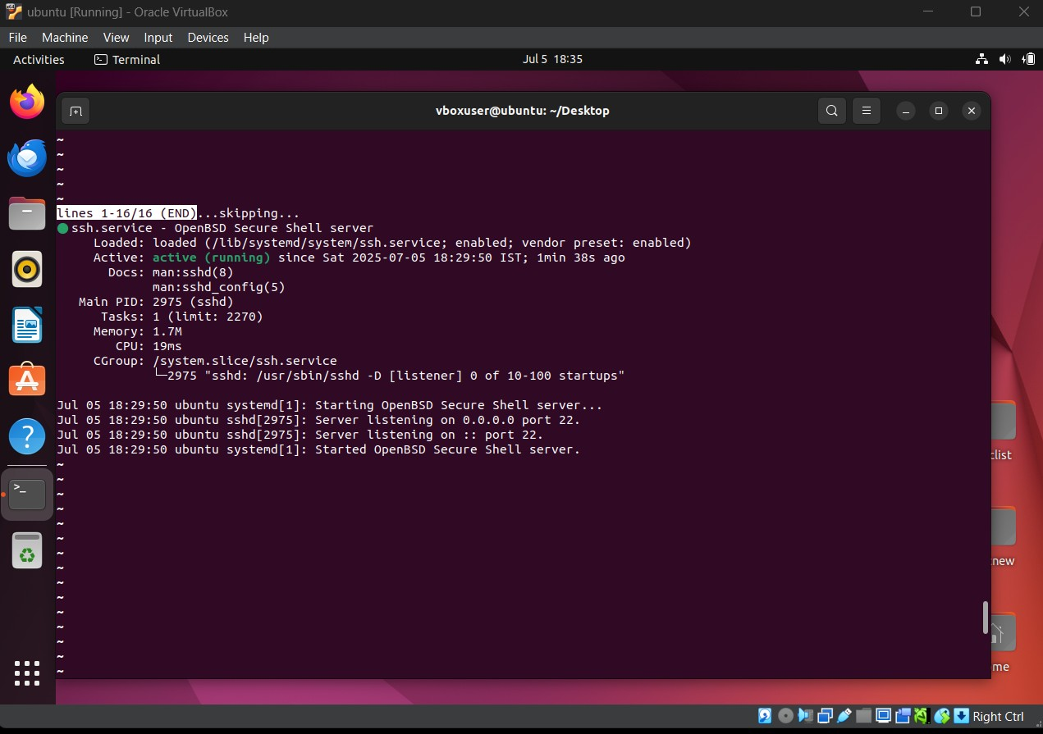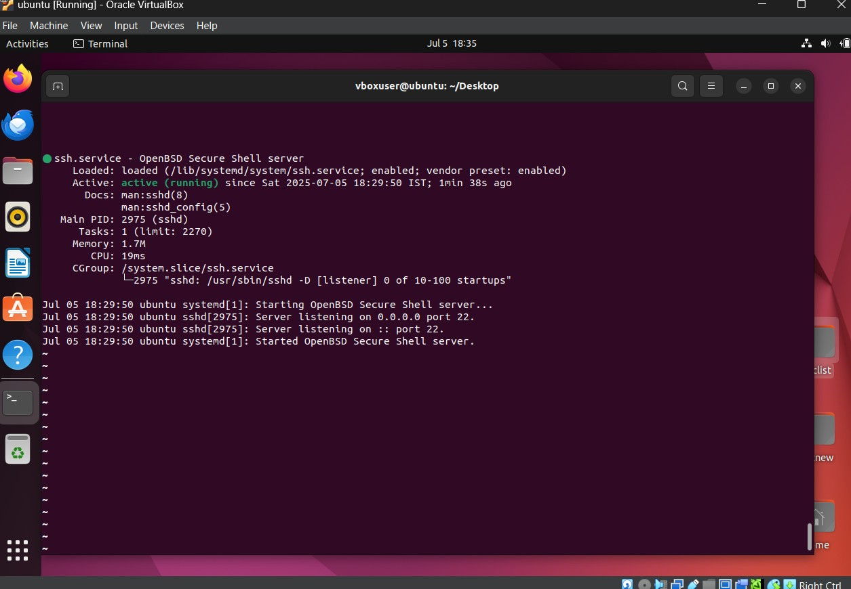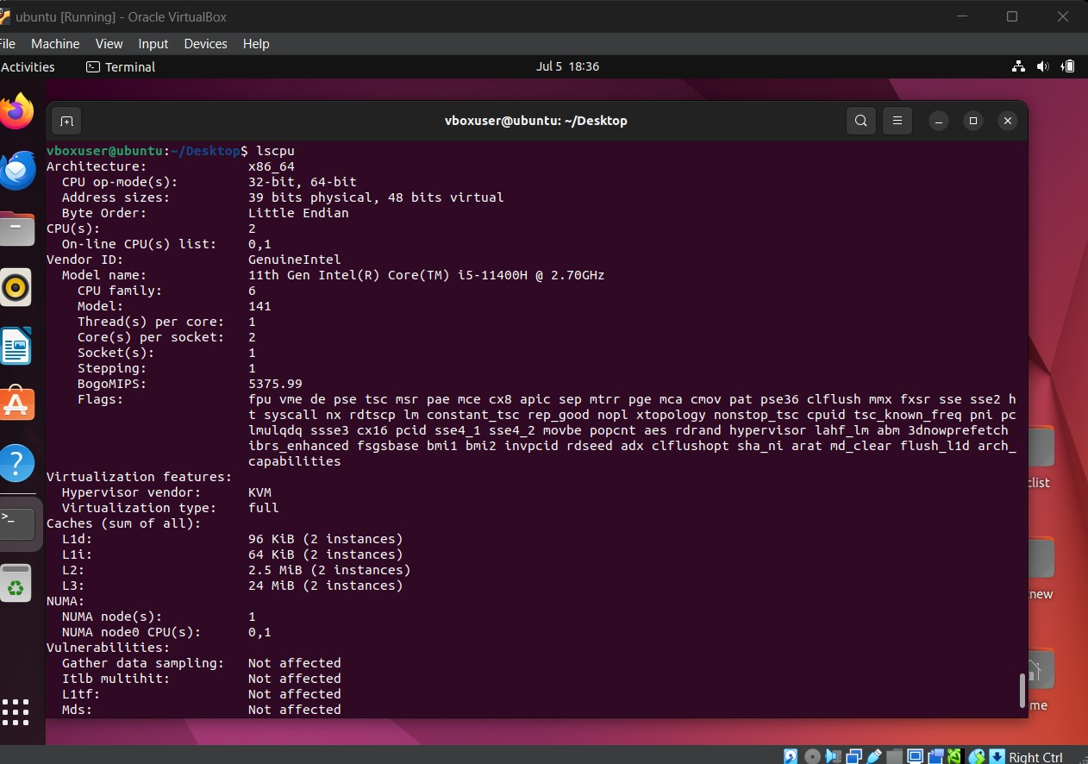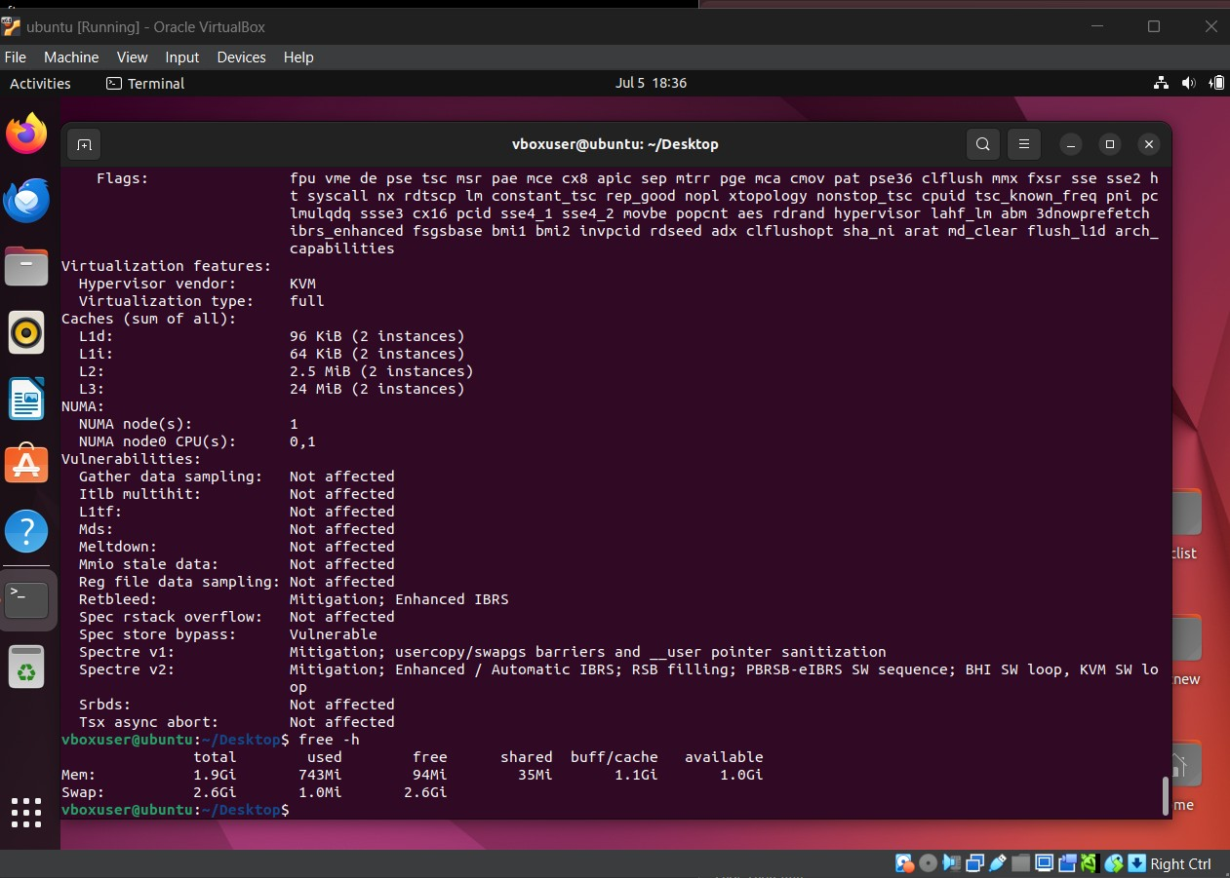

Figure 1: Virtual Machine - Terminal Open

lscpu free -

h ip a

Listing 2: CPU

# Task 2: System Command Mastery (20 marks)

Objective

Automate key system tasks using bash scripting.

Script Name sys_monitor.sh

Script Functionality

* Top 5 memory-consuming processes
* List open ports and associated services
* Count number of .sh and .conf files in /etc and /home
* Schedule cron job every 5 minutes
* Backup /var/log to user’s home

|  |
| --- |
| *#!/bin/bash*  echo "Top 5 memory-consuming processes:" ps aux -sort=-%mem | head -n 6  echo "Open ports:" ss tuln  echo "File count in /etc and /home:" find /etc -type f -name "*.conf" | wc -l find /home -type f -name  "*.sh" | wc -l  echo "Creating log backup..." tar -czf  ~/logs_backup.tar.gz /var/log |

Listing 3: System Monitoring Bash Script

Output Screenshot

images/sys_monitor_output.png

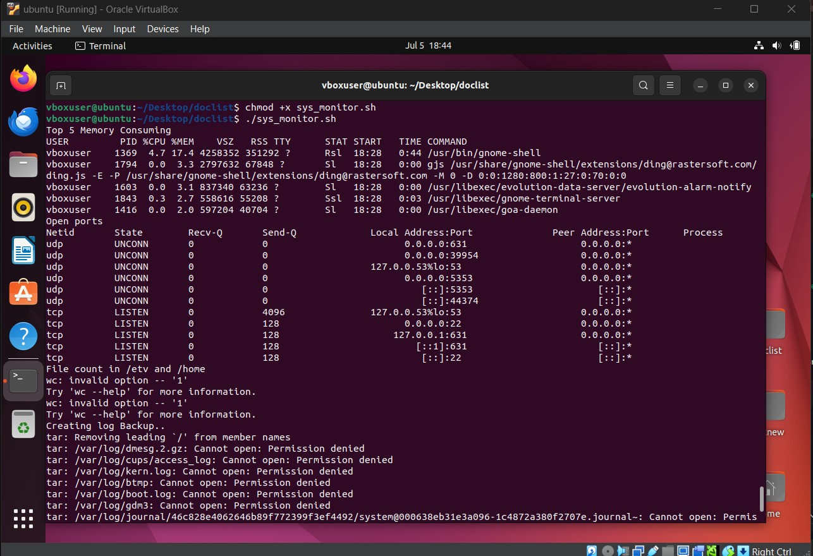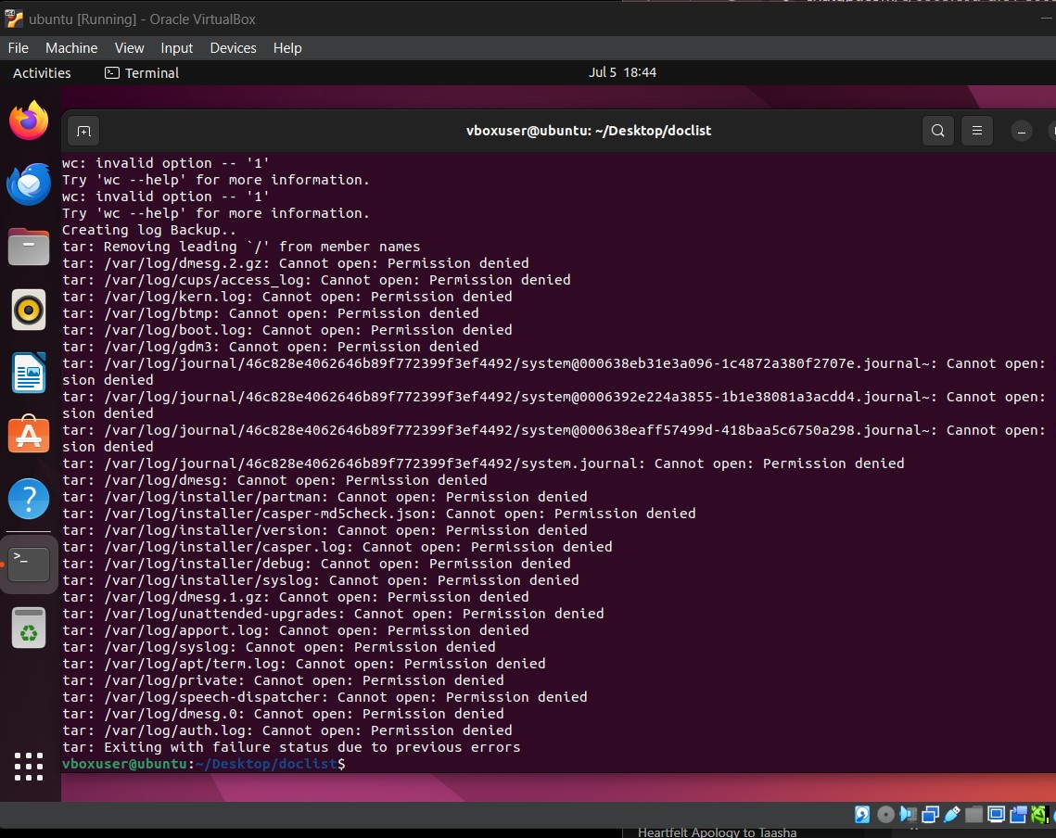

Figure 2: Output of sys_monitor.sh Script

# Task 3: Linux Internals with Python (30 marks)

Objective

Extract system details and manipulate files using Python.

Script Name sysinfo.py Script Objectives

* Extract CPU info from /proc/cpuinfo
* Parse users from /etc/passwd
* Create folder structure and move shell scripts

|  |
| --- |
| import os  *# CPU Info* with open("/proc/cpuinfo") as f:  for line in f:  if "model name" in line:  print(line.strip()) break  *# Extract bash users* with open("/etc/passwd") as f:  users = [line.split(":")[0] for line in f if "/bin/bash" in line]  print("Users with bash shell:", users)  *# Create folders and move files* os.makedirs("/home/youruser/LinuxExp/Week1/Day1", exist_ok=True) os.system("mv /home/youruser/*.sh /home/youruser/LinuxExp/Week1/Day1/") |

Listing 4: System Info Python Script

Sample Output Screenshot

images/sysinfo_output.png

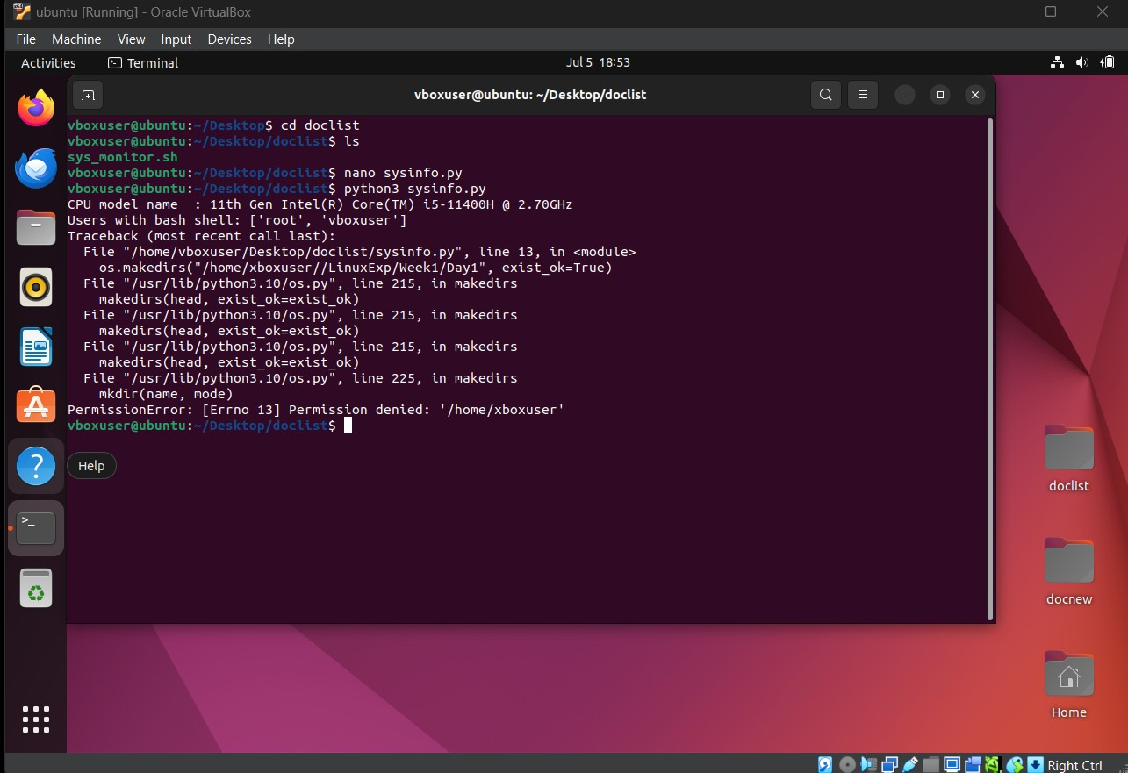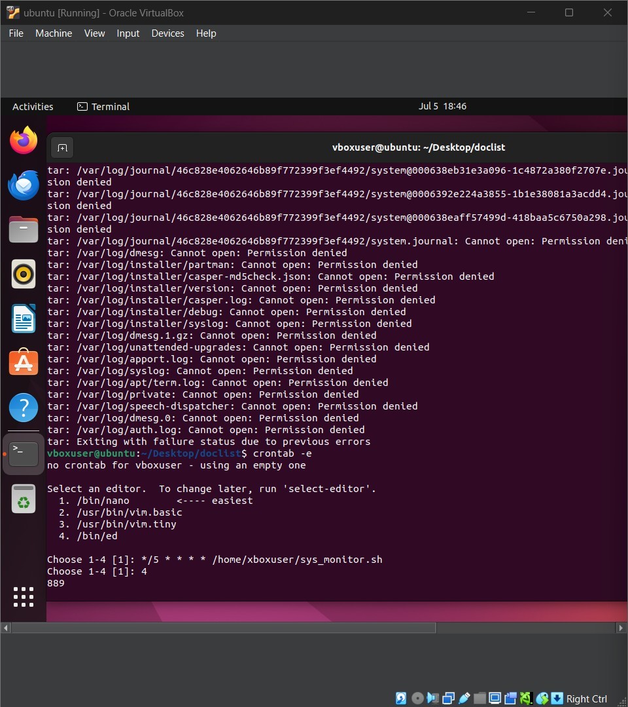

Figure 3: System Info Script Output

# Task 4: Bonus – Disk Usage Visualization (10 bonus marks)

Objective

Visualize disk usage using Matplotlib and Linux commands.

Script Name disk_pie.py

|  |
| --- |
| import os import matplotlib.pyplot as  plt labels = [] sizes = []  for item in os.listdir("/home/youruser"):  path = os.path.join("/home/youruser", item) if os.path.isdir(path):  size = os.popen(f"du -sh {path}").read().split()[0] size_val = float(size.replace(’M’, ’’).replace(’K’, ’’).replace(’G’, ’’)) labels.append(item) sizes.append(size_val)  plt.pie(sizes, labels=labels, autopct=’%1.1f%%’) plt.title("Disk Usage in /home") plt.savefig("disk_usage.png") plt.show() |

Listing 5: Disk Usage Pie Chart Script

Page

image

/disk_usage.png

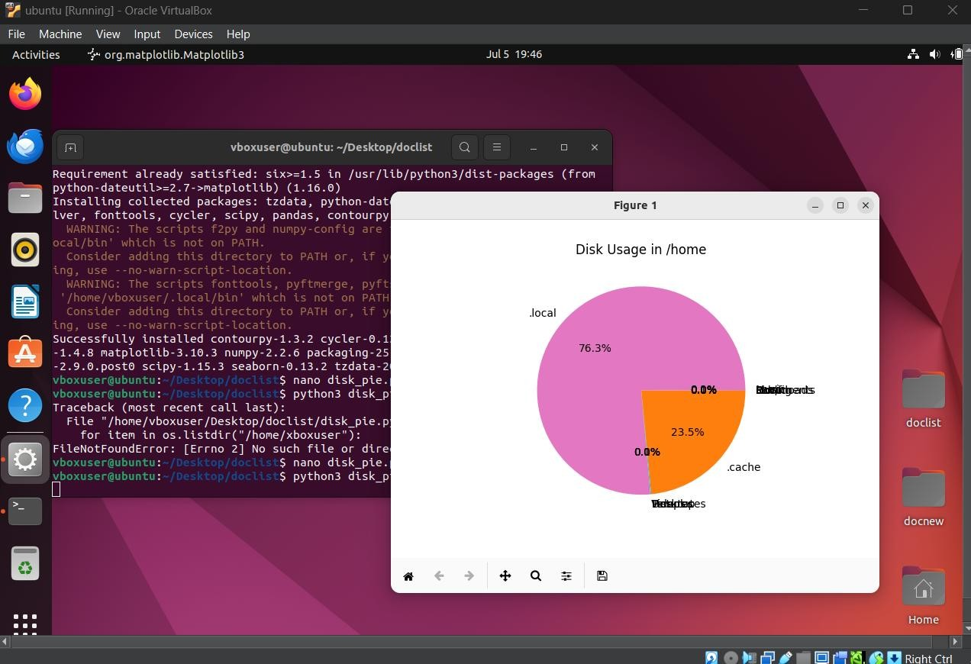

Figure 4: Pie Chart - Disk Usage in Home Directory

Conclusion

This assignment introduced key aspects of Linux system usage, VM configuration, and scripting. Tasks such as automated backups, service analysis, and cron jobs provided realistic DevOps exposure.

Page